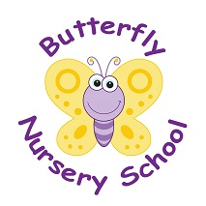
Butterfly Nursery School
Church Road
Horne
Surrey
RH6 9LA
01342 843655
POLICY: Early Learning Opportunities Statement (EYFS 1.1-1.10)
We set out to support all children attending the nursery to attain their maximum potential within their individual capabilities. A personalised record of each child’s development is maintained, showing their abilities, progress, interests and areas needing further staff or parental assistance. We acknowledge that children learn in different ways and at different rates and plan for this accordingly.

The staff are very aware of the importance of a positive play environment for the child, so they may develop good social skills and an appreciation of all aspects of this country’s multi- cultural society.
Planning of the learning experience by the staff is further designed to ensure, as far as practical, equality of opportunity between all children and that it celebrates diversity.

We promote the relevant frameworks and curriculum set by the Department for Education to support and enhance children’s learning and development holistically through play based activities. We view all aspects of learning and development equally and ensure a flexible approach is maintained, which responds quickly to children’s learning and developmental needs. We develop tailor made activities based on observations which inform future planning and draw on children’s needs and interests. This is promoted through a balance of adult-led and child-initiated opportunities both indoors and outdoors.

We acknowledge parents as primary educators and encourage parental involvement as outlined in our Parents and Carers as Partners policy. We build strong home links in order to enhance and extend children’s learning both within the nursery environment and in the child’s home.

This policy was adopted on: | Signed on behalf of the nursery | Date disseminated to staff | Date for review

